**Use Case Flow – determine funds available**

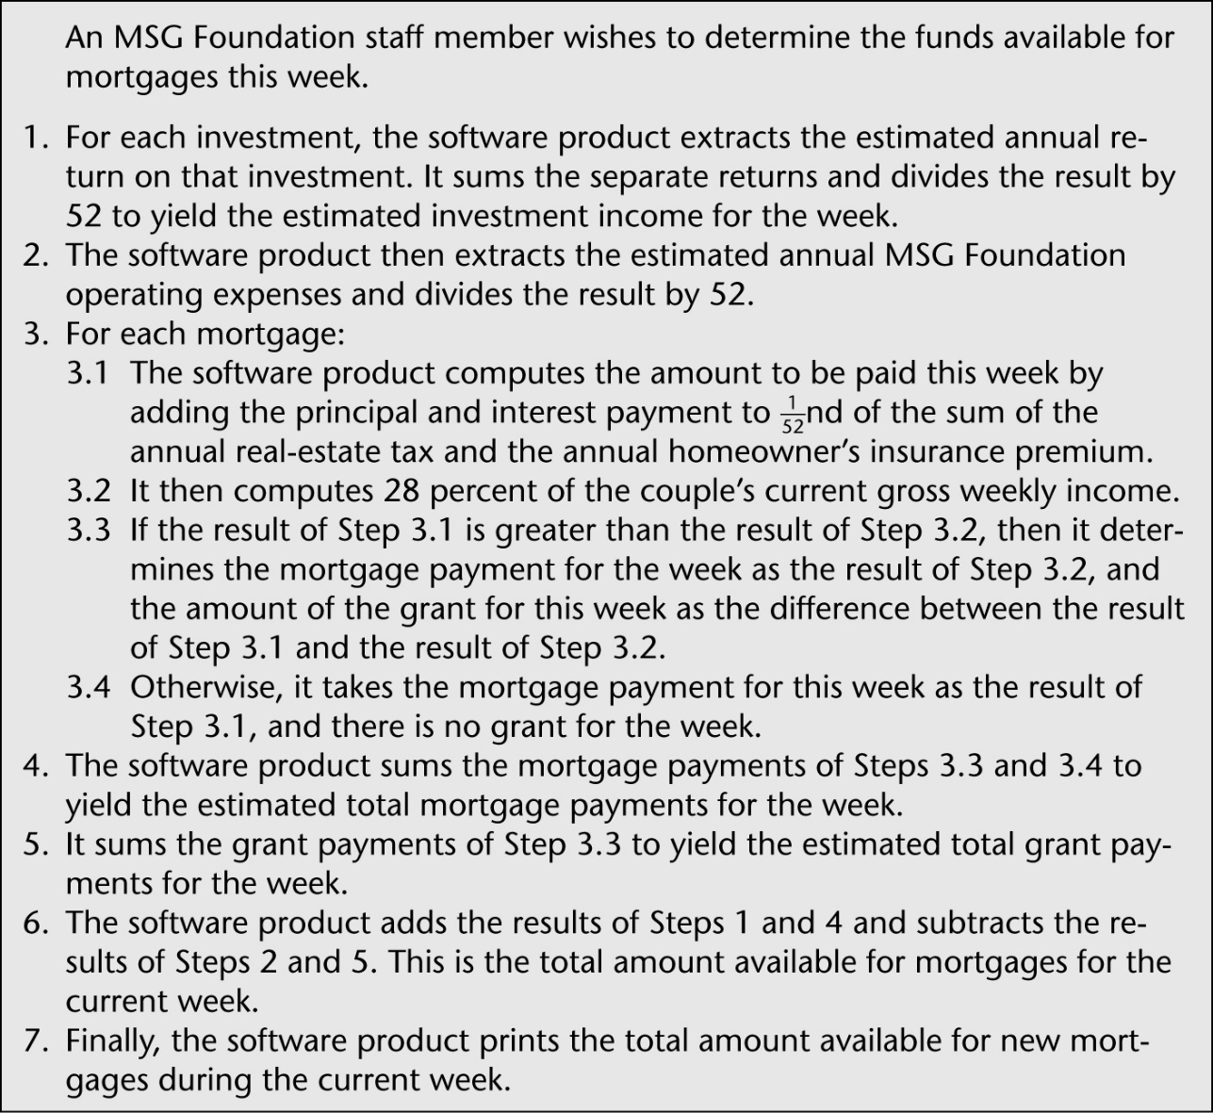

**Initial Robustness Diagram**

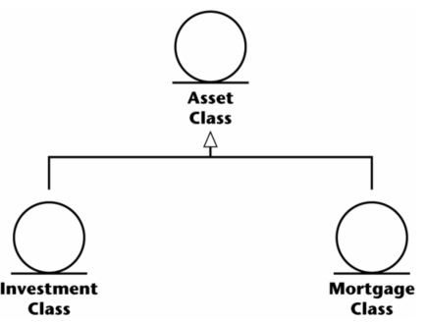

**Initial Class Diagram**

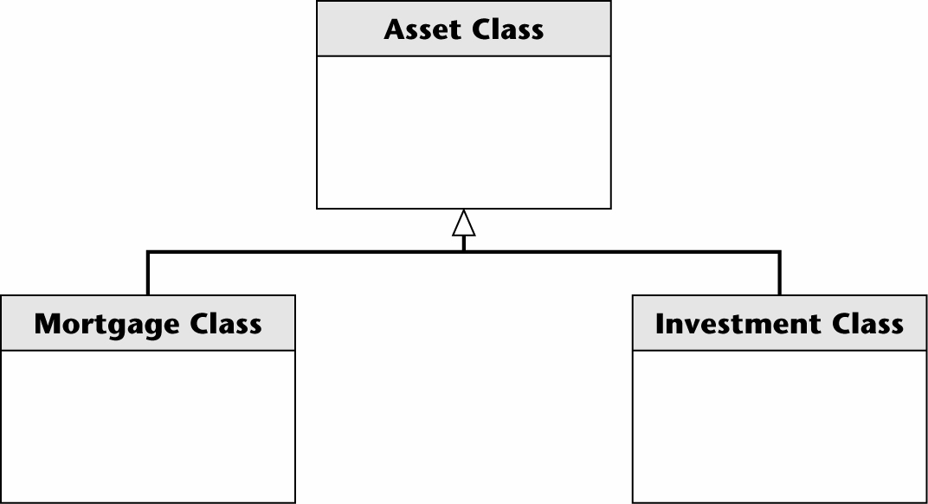

**Use Case Summary Diagram**

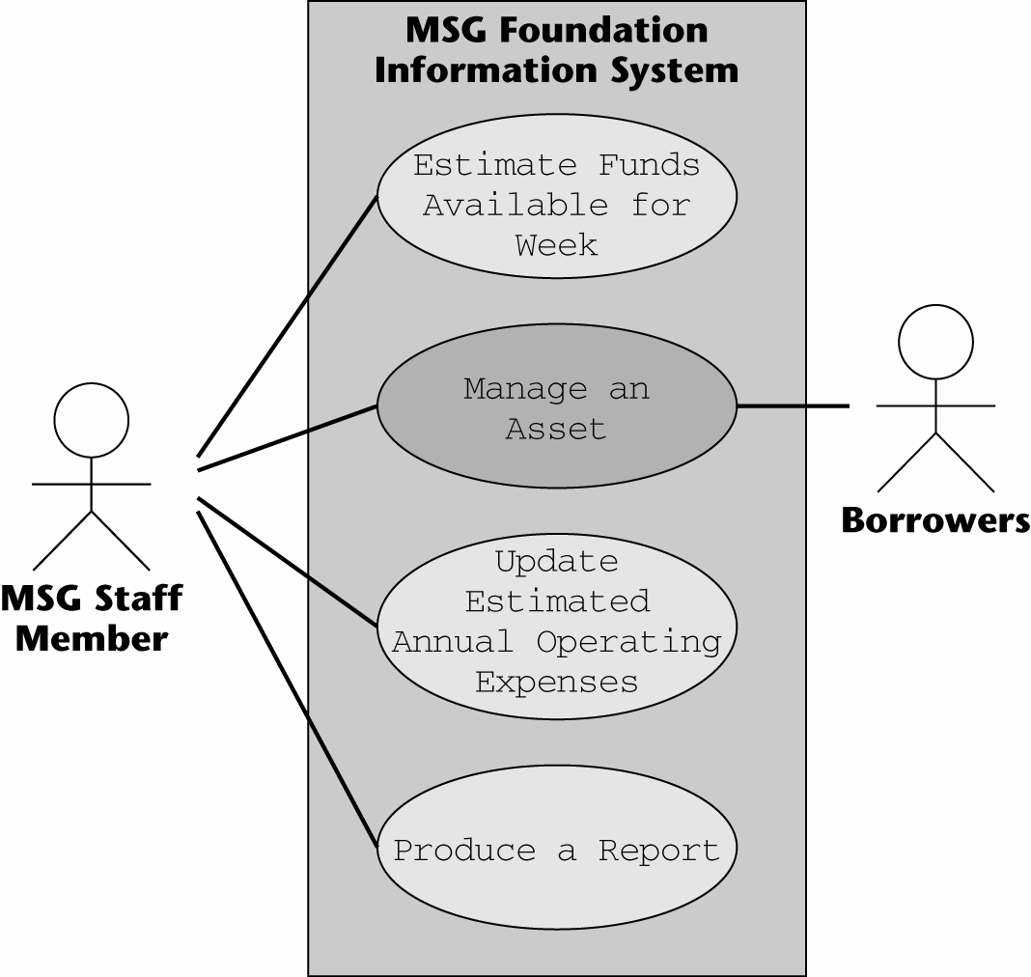

**Updated Class Diagram**

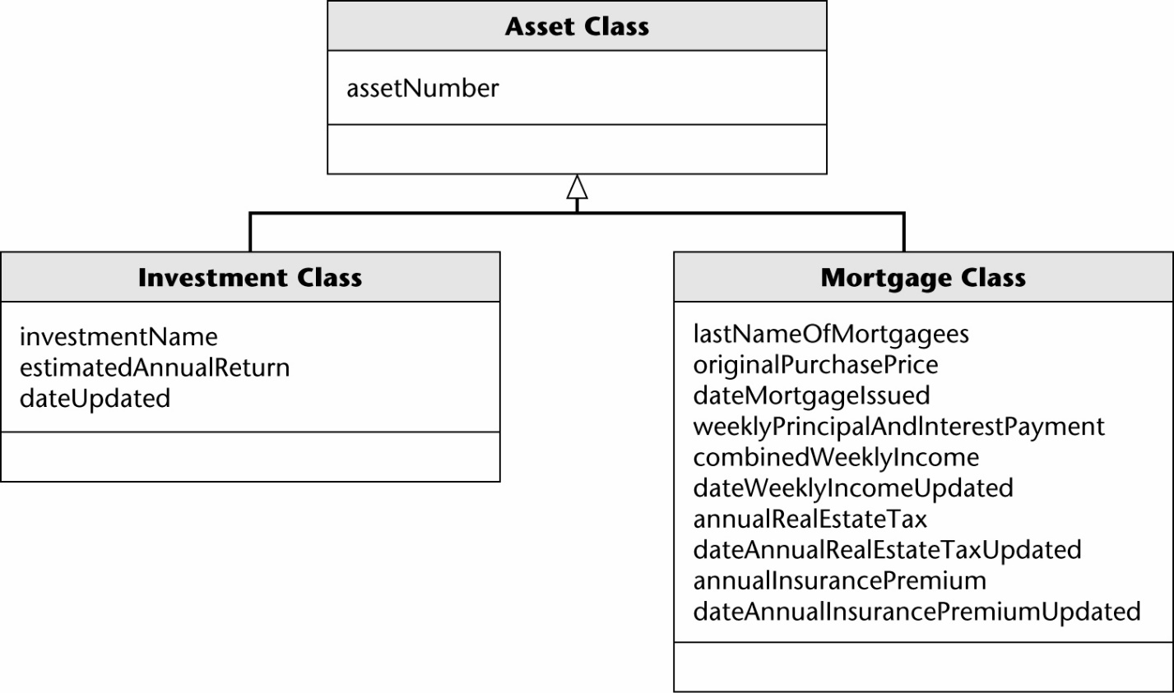

**State Diagram**

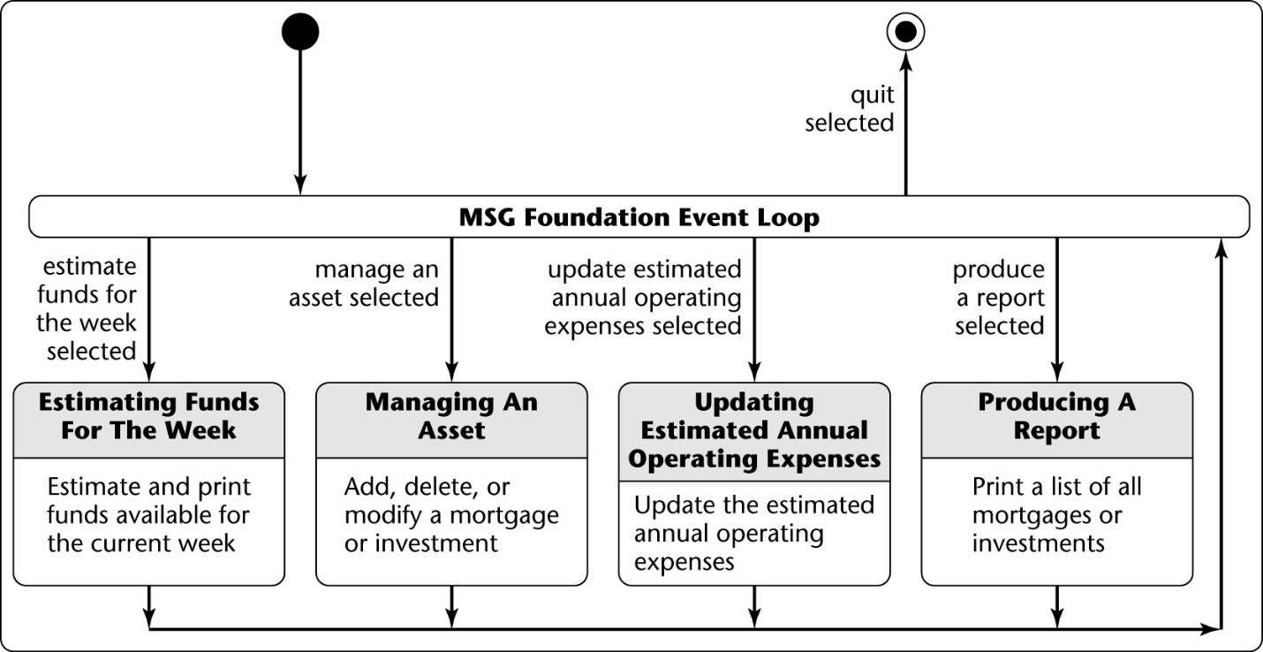

**Interface**

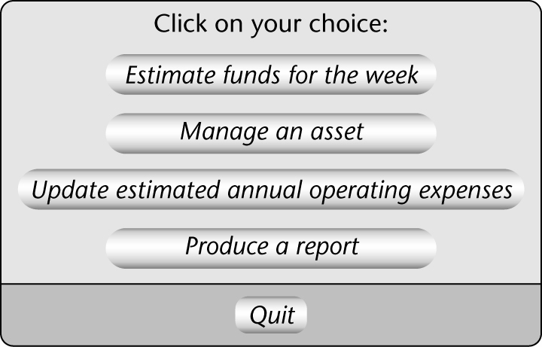

**Updated Robustness Diagram**

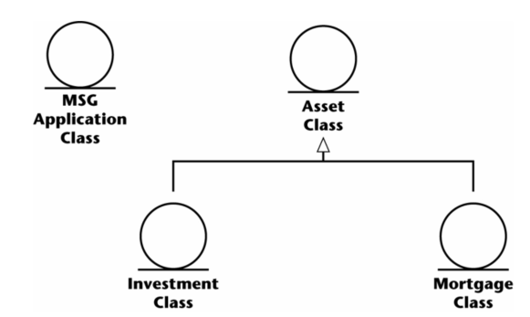

**Updated Class Diagram**

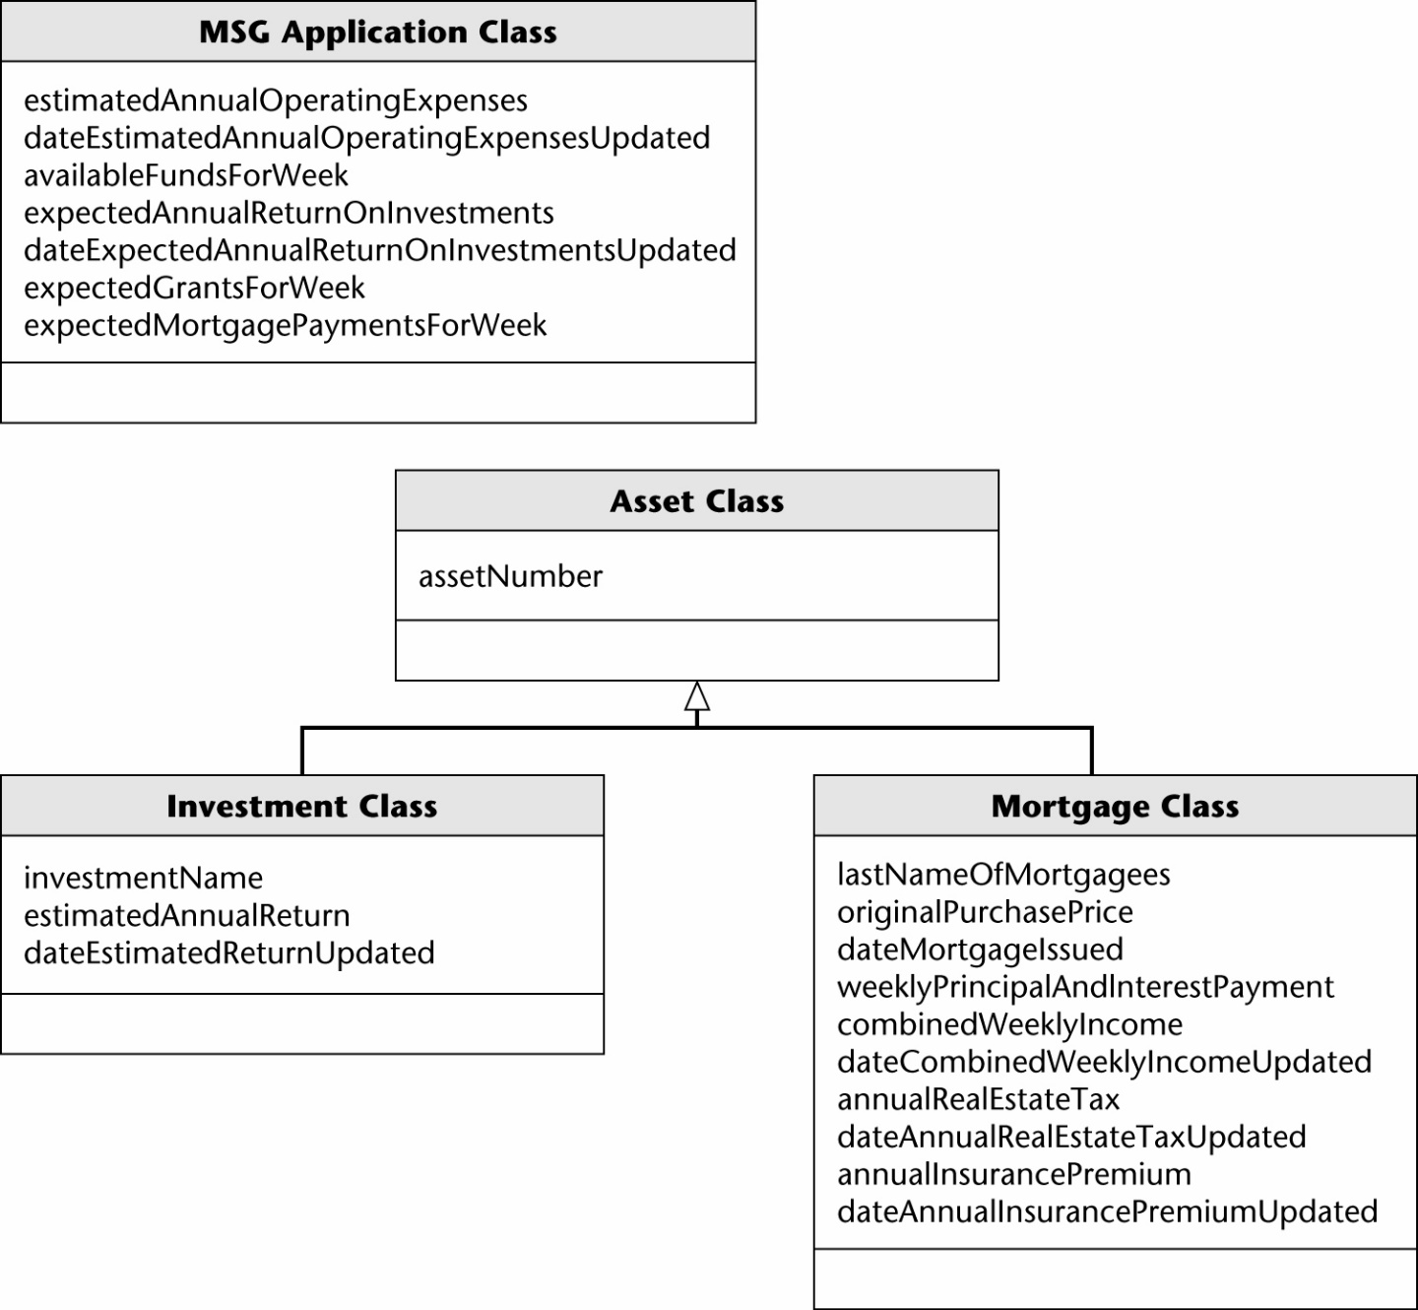

**Estimated Fund Available Use Case Diagram**

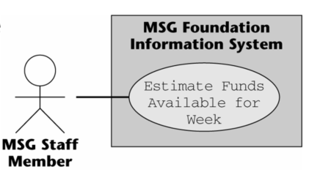

**Intro and Use Case Flow**

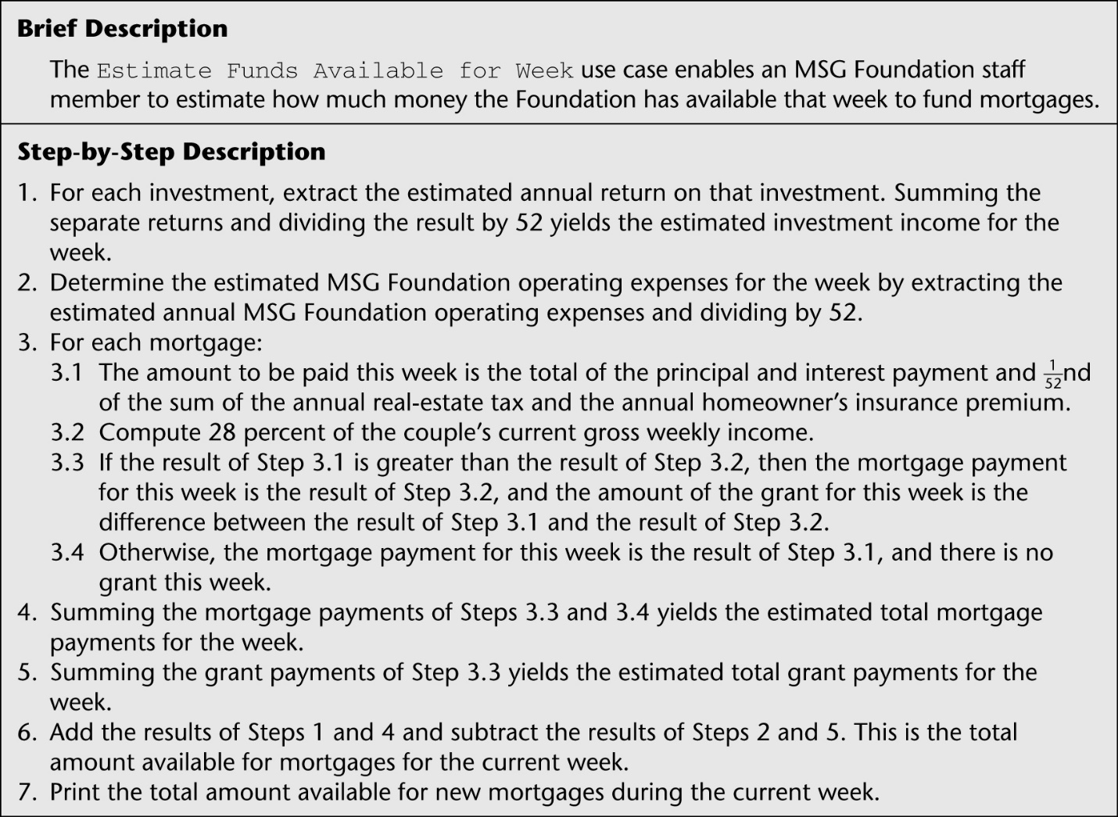

**Use Case Robustness Diagram**

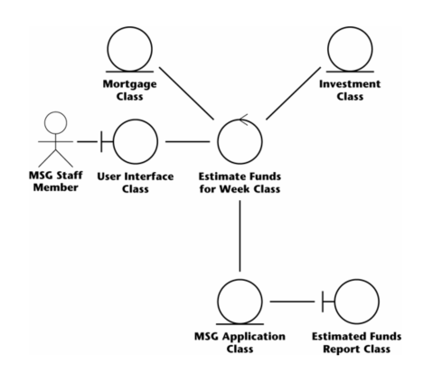

**Modified Use Case Flow**

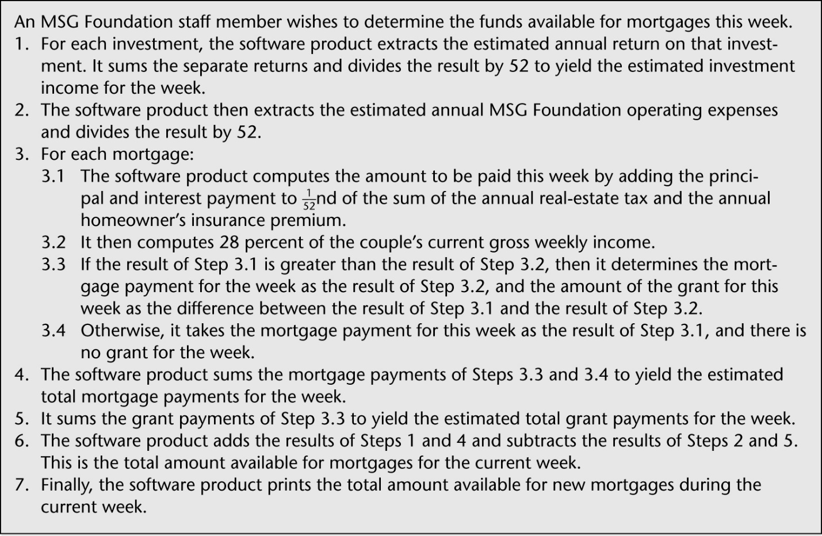

**Collaboration/Communication Diagram**

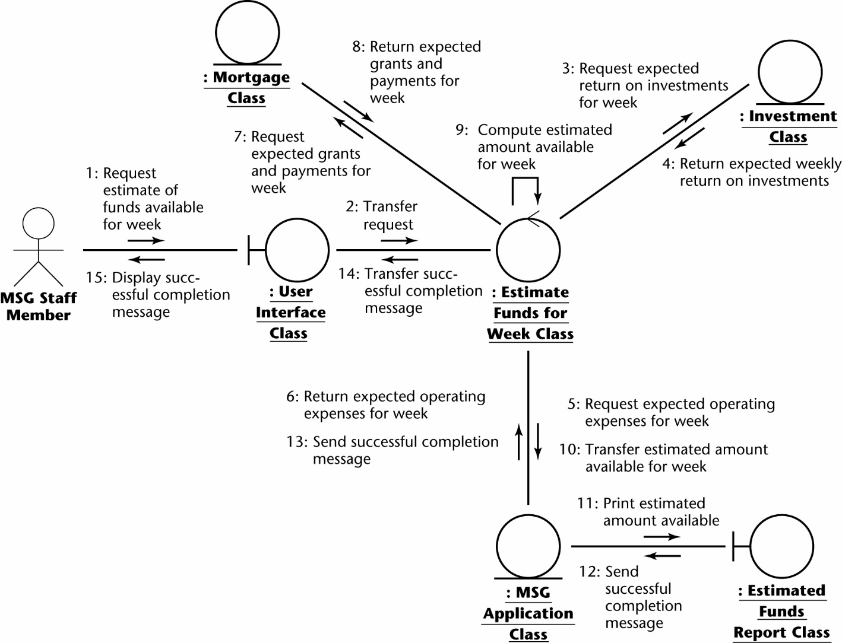

**Sequence Diagram**

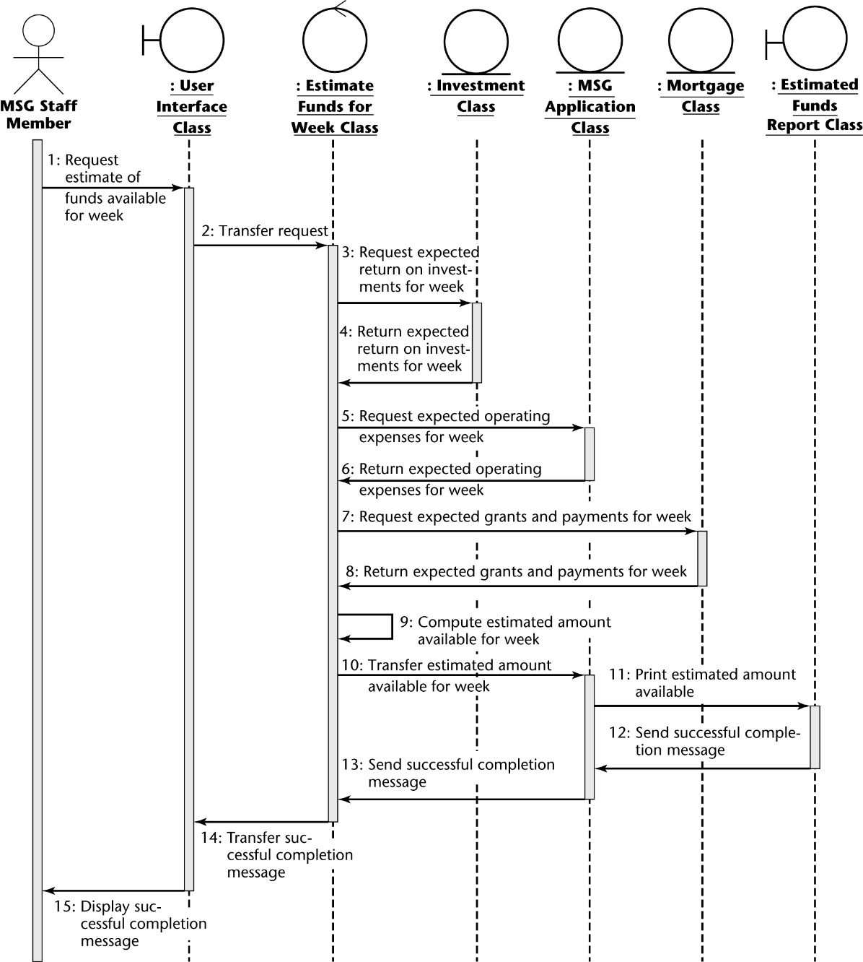

**Another Use Case: Manage an Asset**

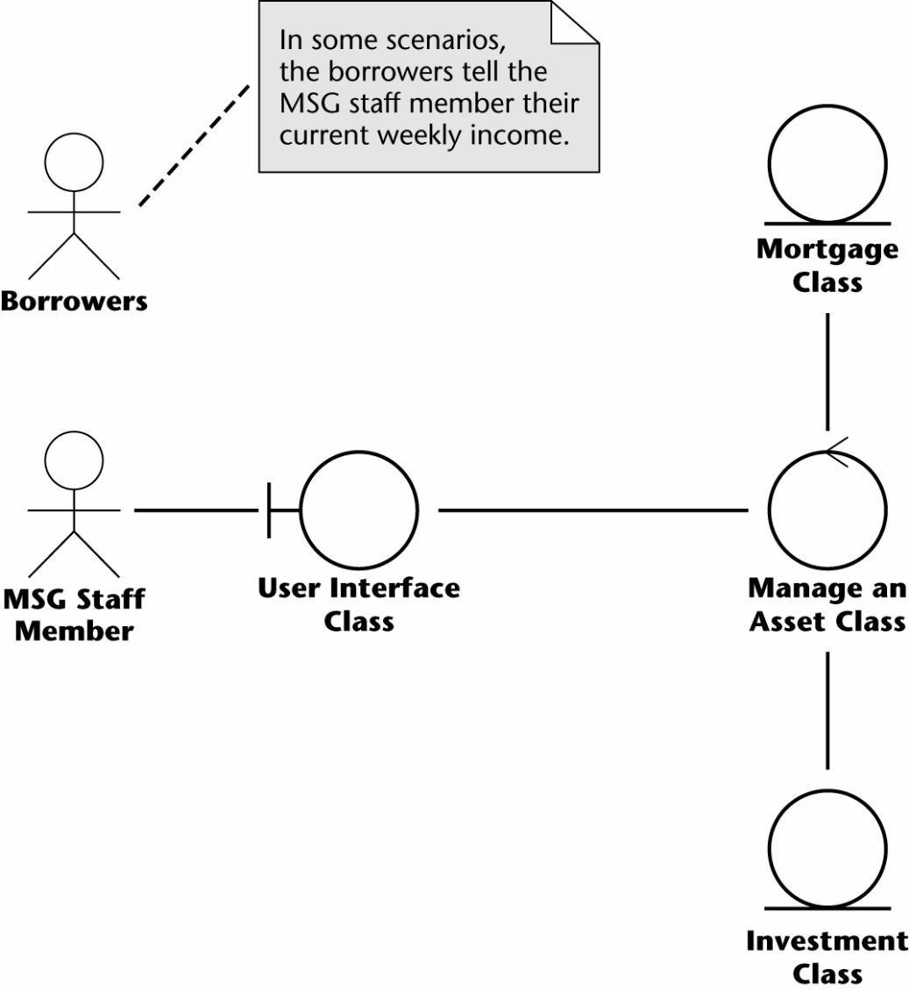

**Use Case Flow**

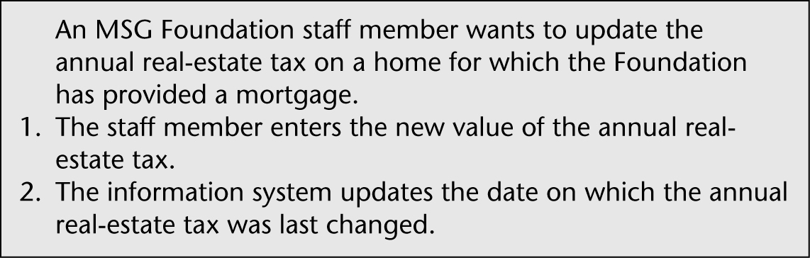

**Collaboration/Communication Diagram**

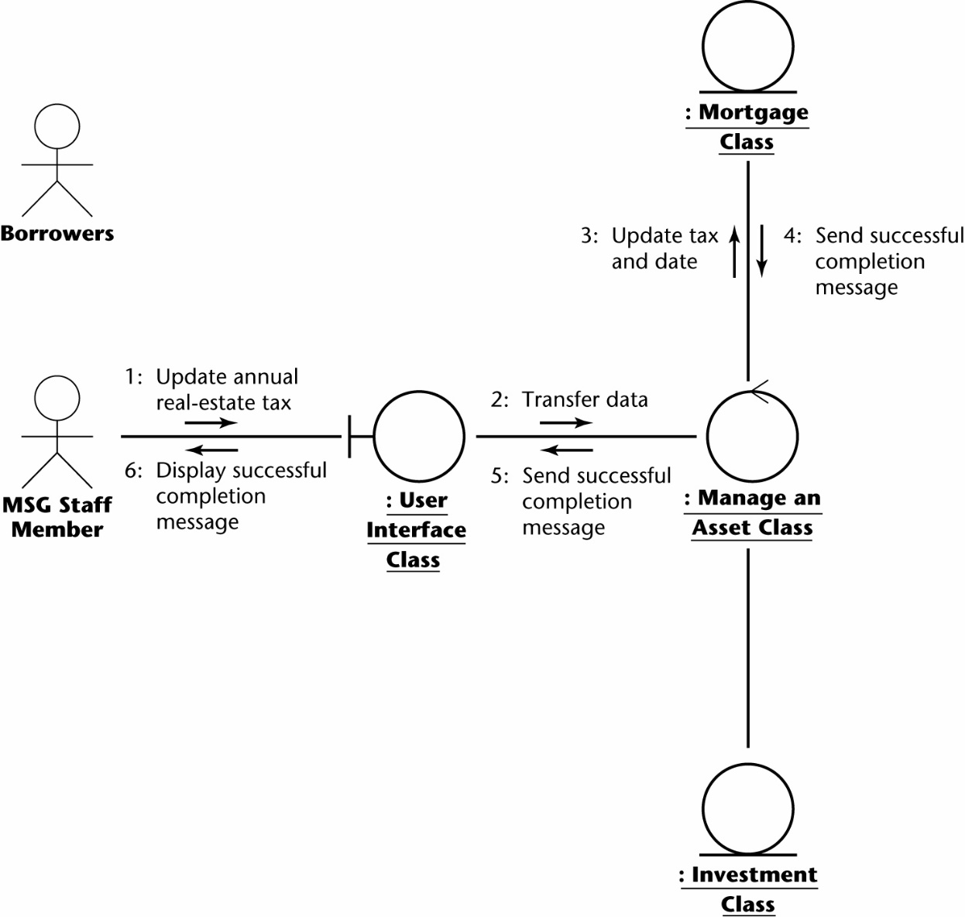

**Sequence Diagram**

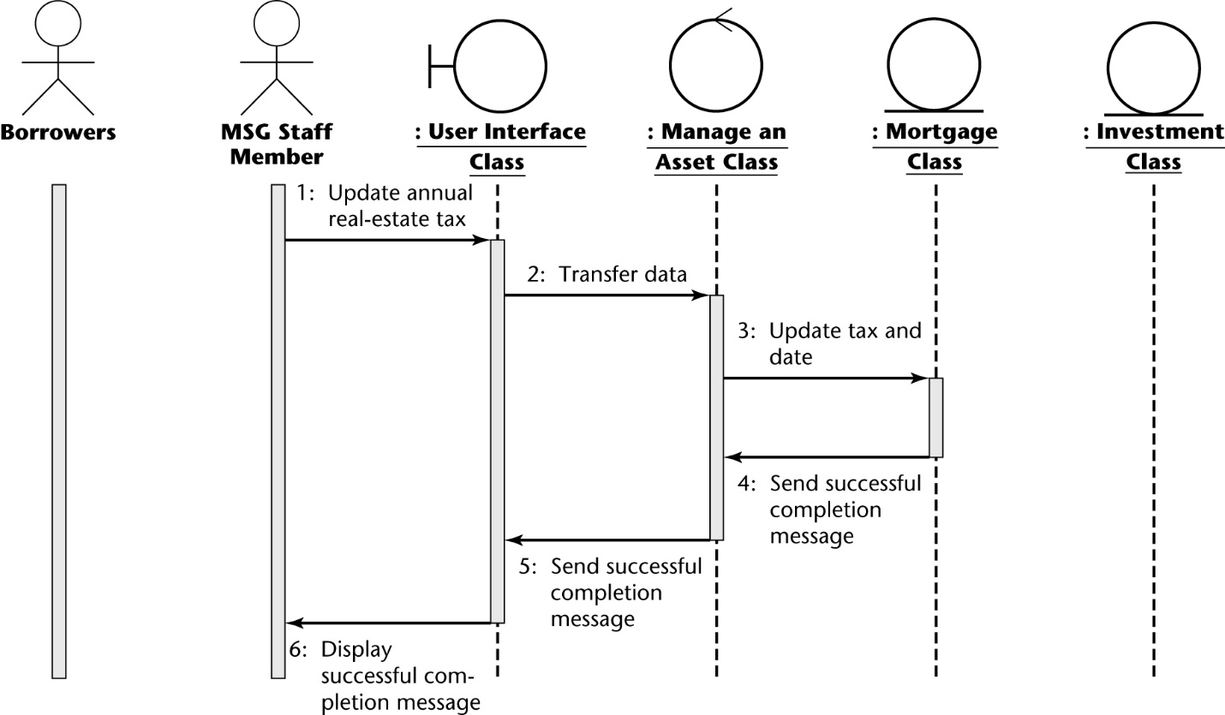

**Another flow in SAME use case**

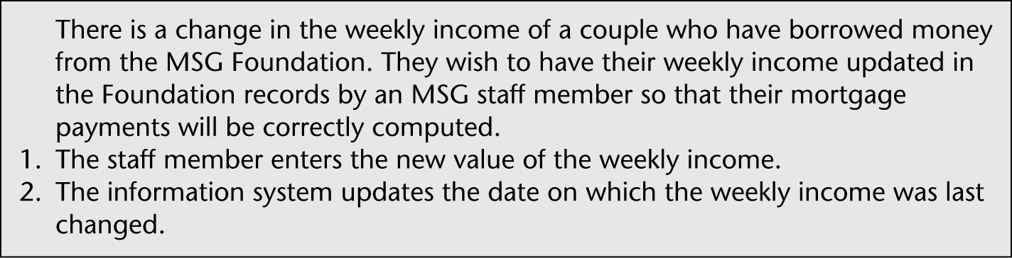

**Collaboration/Communication Diagram**

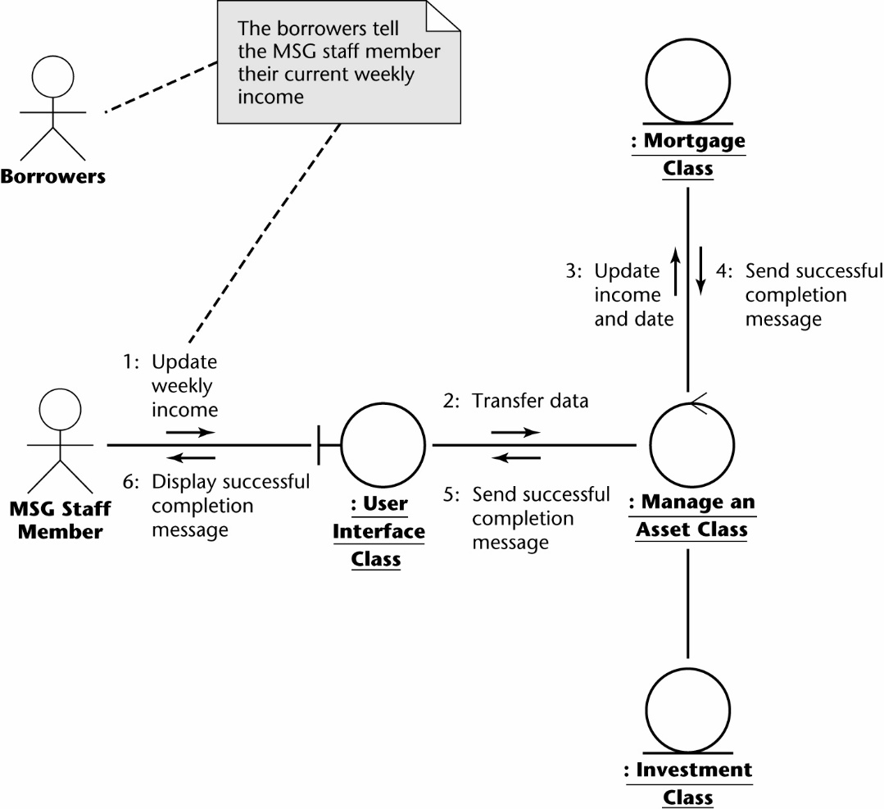

**Sequence Diagram**

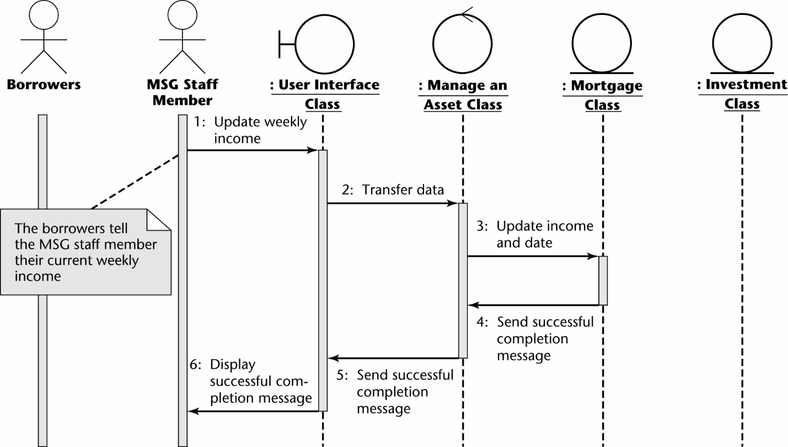

**Revise Interface**

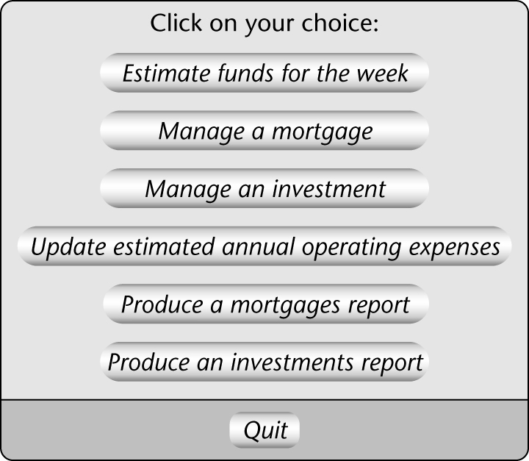

**Another Use Case – Produce a Report**

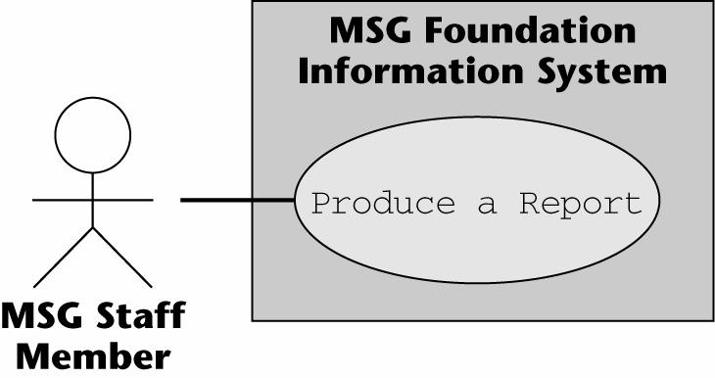

**Intro and Flow in Use Case**

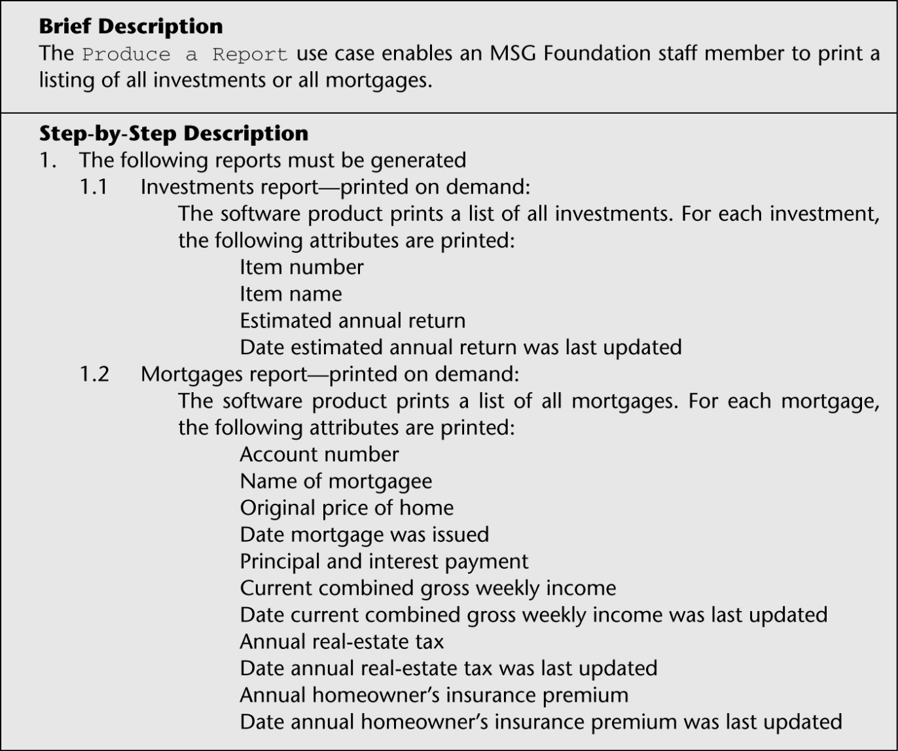

**Robustness Diagram**

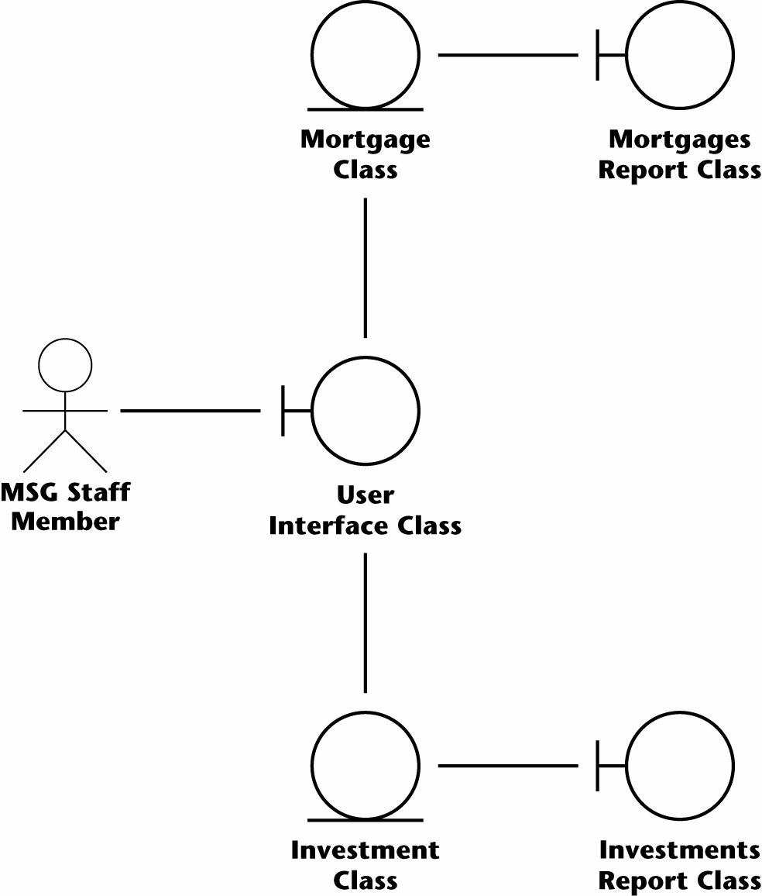

**One Scenario from Use Case**

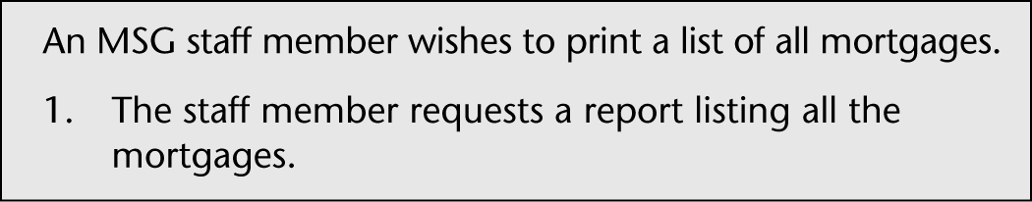

**Collaboration/Communication Diagram**

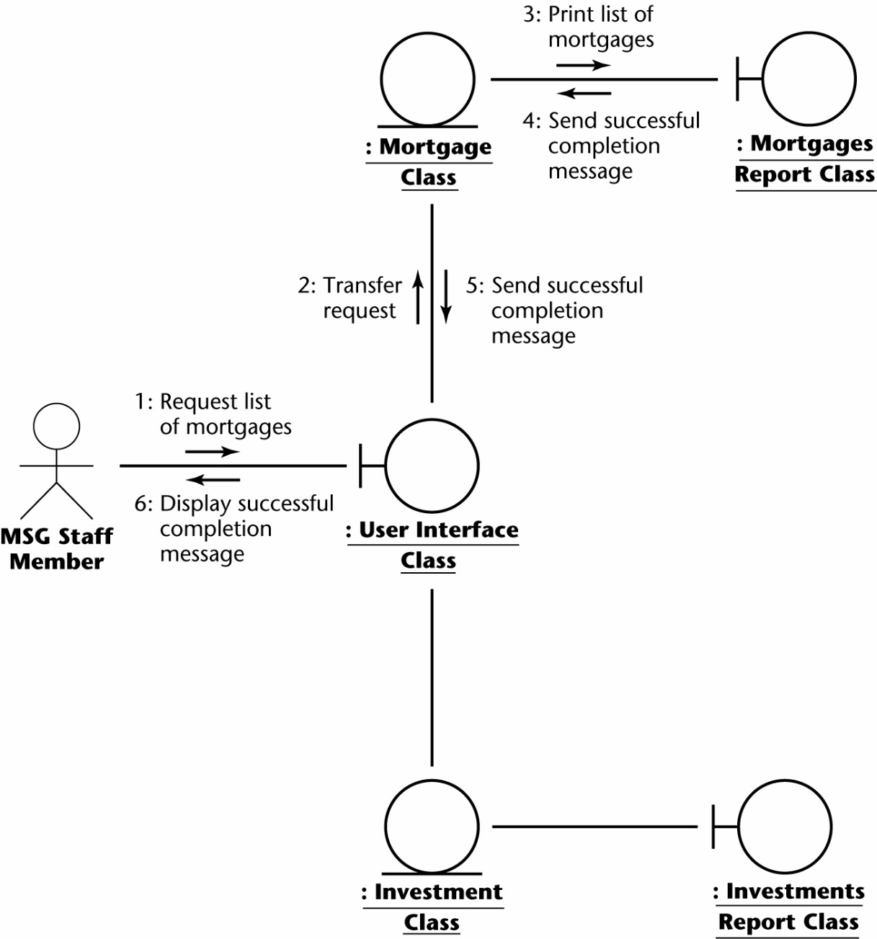

**Sequence Diagram**

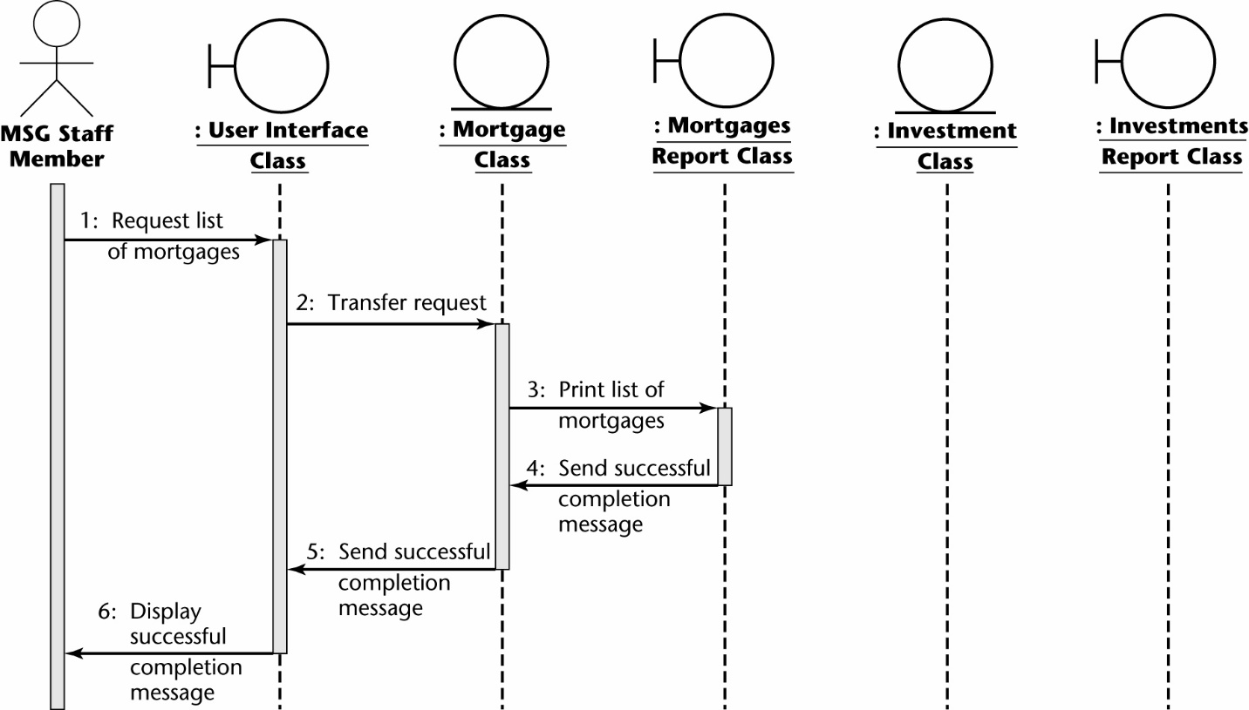

**Another Scenario**

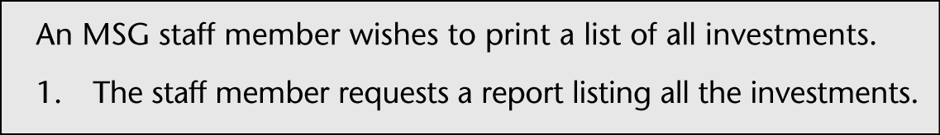

**Collaboration/Communication Diagram**

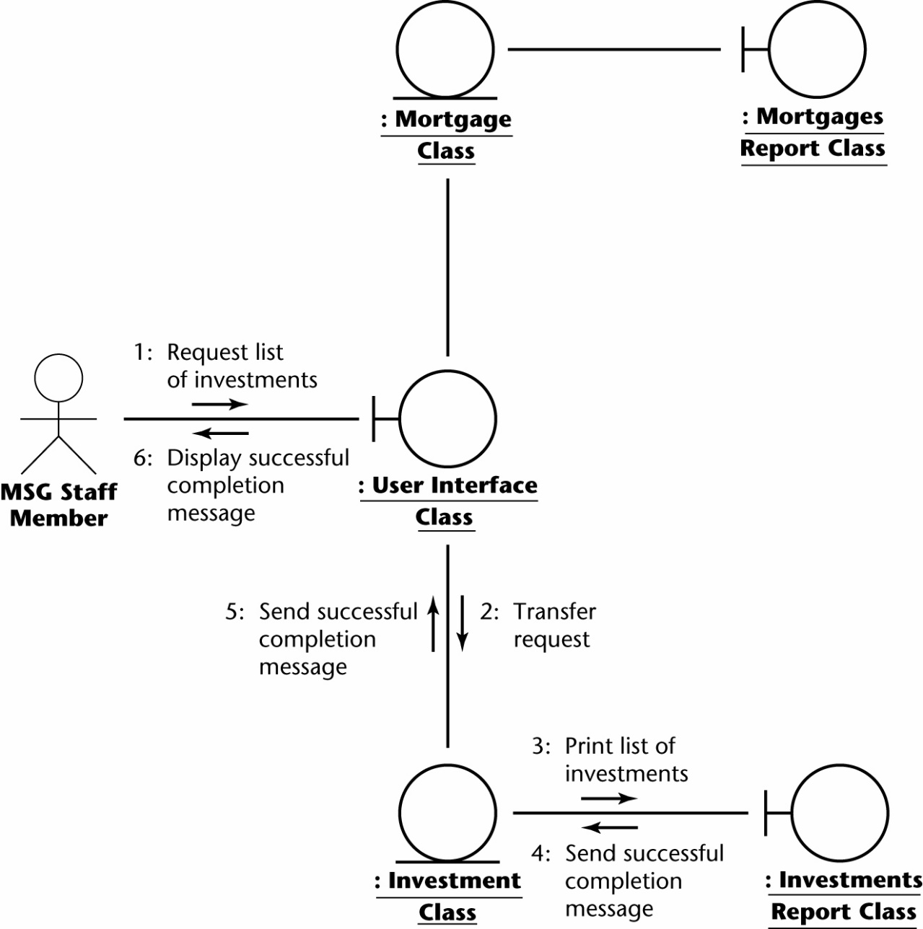

**Sequence Diagram**

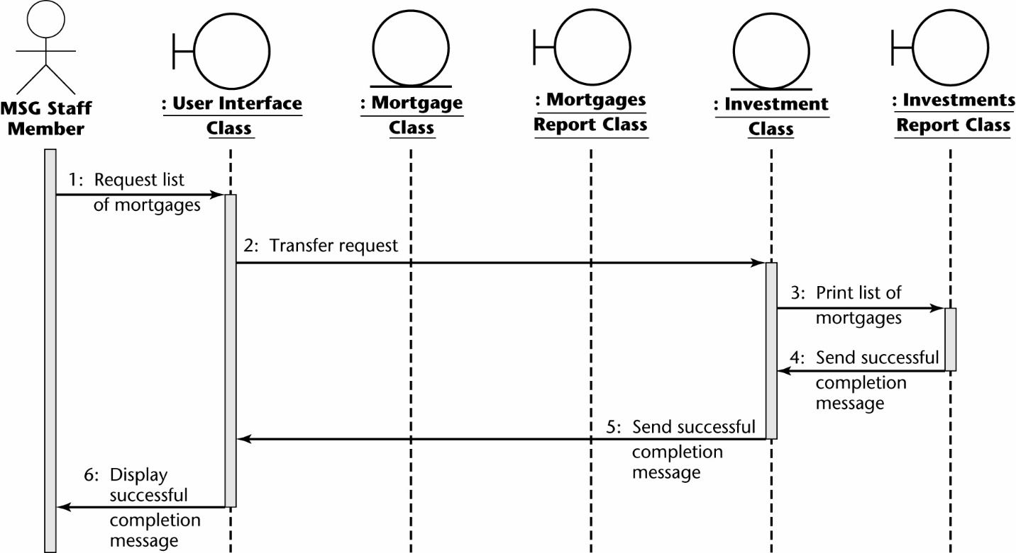

**COMBINED Robustness Diagram**

